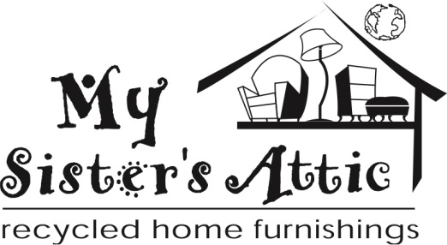

FOR IMMEDIATE RELEASE
THURSDAY, JANUARY 14, 2016

CONTACT: Lisa Pagel
lisap@mysisterscloset.com
602.952.9616

WINTER SALE AND SPRING UNVEILING
PROGRESSIVE SALE STARTS JANUARY 30
SPRING REVEAL ON FEBRUARY 13

(PHOENIX, SCOTTSDALE and CHANDLER, ARIZONA) – Celebrate the end of winter and the start of spring in fashion with
My Sister’s Closet, Well Suited and My Sister’s Attic stores.

Winter Progressive Sale – Saturday, January 30, 9:00 a.m.

Visit any My Sister’s Closet or Well Suited store location to enjoy great deals on your favorite designers. Savings start at 20% off of everyday great values, up to 70% off as the sale progresses. My Sister’s Attic stores will offer savings on select “red dot” items.

- 20% off January 30 - 31
- 30% off February 1 - 3
- 40% off February 4 - 5
- 50% off February 6 - 9
- 70% off February 10 - 12 (STORES CLOSE EARLY AT NOON ON FRIDAY, FEBRUARY 12)

Everything on sale must be sold by Noon on Friday, February 12 to make room for the spring reveal. Items that are not sold will be donated to various local charities, including My Sisters’ Charities Thrift Store, located in Chandler.

Spring Unveiling – Saturday, February 13, 8:00 a.m. My Sister’s Closet and Well Suited

- Want to be the first to shop at Lincoln Village or Pinnacle Peak? Call 602.952.9616 to purchase a V.I.P. ticket to shop those three stores at 7 a.m. on February 13. Tickets are limited to 50 shoppers, $100 each.
- My Closet and Well Suited Stores open at 8 a.m. for the annual Spring Unveiling
- Get in line early at your favorite location to shop over 100,000 never-before-seen spring items

All stores are now accepting spring designer consignment merchandise that is “Cute, Clean and Current”.

Like My Sister’s Closet on Facebook , follow My Sister’s Closet.com on Instagram, and sign up to get email updates at www.mysisterscloset.com to receive updates of the hottest items, special sales and events.

Arizona Locations
Desert Village at Pinnacle Peak
23269 N. Pima Rd. Scottsdale, AZ 85255 Phone: 480-419-6242
Lincoln Village in Scottsdale
6204 N. Scottsdale Rd. Scottsdale, AZ 85253 Phone: 480-443-4575
Town & Country in Phoenix
4869 N. 20th St. Phoenix, AZ 85016 Phone: 602-954-6080
Las Tiendas in Chandler
2915 S. Alma School Rd. Chandler, AZ 85248 Phone: 480-722-1822

California Locations
Costa Verde/San Diego
8610 Genesee Ave. San Diego, CA 92122 Phone: 858-455-0045
Encinitas
146 N. El Camino Real Encinitas, CA 92024 Phone: 760-436-3600

Arizona Locations
Desert Village at Pinnacle Peak
23269 N. Pima Rd. Scottsdale, AZ 85255 Phone: 480-419-6242
Lincoln Village in Scottsdale
6204 N. Scottsdale Rd. Scottsdale, AZ 85253 Phone: 480-556-9750
Town & Country in Phoenix
4859 N. 20th St. Phoenix, AZ 85016 Phone: 602-840-5605

California Location
Encinitas
146 N. El Camino Real Encinitas, CA 92024 Phone: 760-436-3600

Arizona Locations
Desert Village at Pinnacle Peak
23435 N. Pima Rd. Scottsdale, AZ 85255 Phone: 480-473-0228
Lincoln Village in Scottsdale
6208 N. Scottsdale Rd. Scottsdale, AZ 85253 Phone: 480-607-4303
44th St in Phoenix
4025 N. 44th St. Phoenix, AZ 85018 Phone: 602-957-2799
Fulton Promenade
4955 S. Alma School Rd. Chandler, AZ 85248 Phone: 480-722-1823

About My Sister’s Closet and Eco-Chic Consignment:

Eco-Chic Consignments. Inc. is a family of three high-end designer consignment concepts: My Sister’s Closet (women), My Sister’s Attic (home furnishings) and Well Suited (men). Each store sells consigned items at 60 to 90% below retail value. Founded 25 years ago, Eco-Chic Consignments, Inc. has grown into a $24+ million business with 15 locations in some of the nicest neighborhoods of Arizona and California. The company ranked # 2896 on the Inc. 5000 List. To learn more about Eco-Chic Consignments, Inc. and its resale brands, visit mysisterscloset.com.

# # #

