FOR IMMEDIATE RELEASE
FRIDAY, NOVEMBER 18, 2016

Contact: Jennifer Parks-Sturgeon
Rose+Moser+Allyn Public and Online Relations
Email: Jparks@RoseMoserAllynPR.com
Cell: 480.495.3806

My Sister’s Closet Holiday Style:
The Traveling Little Black Dress
Take A Classic LBD from the Office to Holiday Dinner

(PHOENIX) – This holiday season My Sister’s Closet is showing how everyone’s holiday staple – the LBD (Little Black Dress), can take you from a trip to the grocery store to a fabulous holiday party. It’s one dress, five ways – the perfect way to be ready for any occasion this busy holiday season. This Blaque Label black dress, only $34.95 at My Sister’s Closet, will take you anywhere.
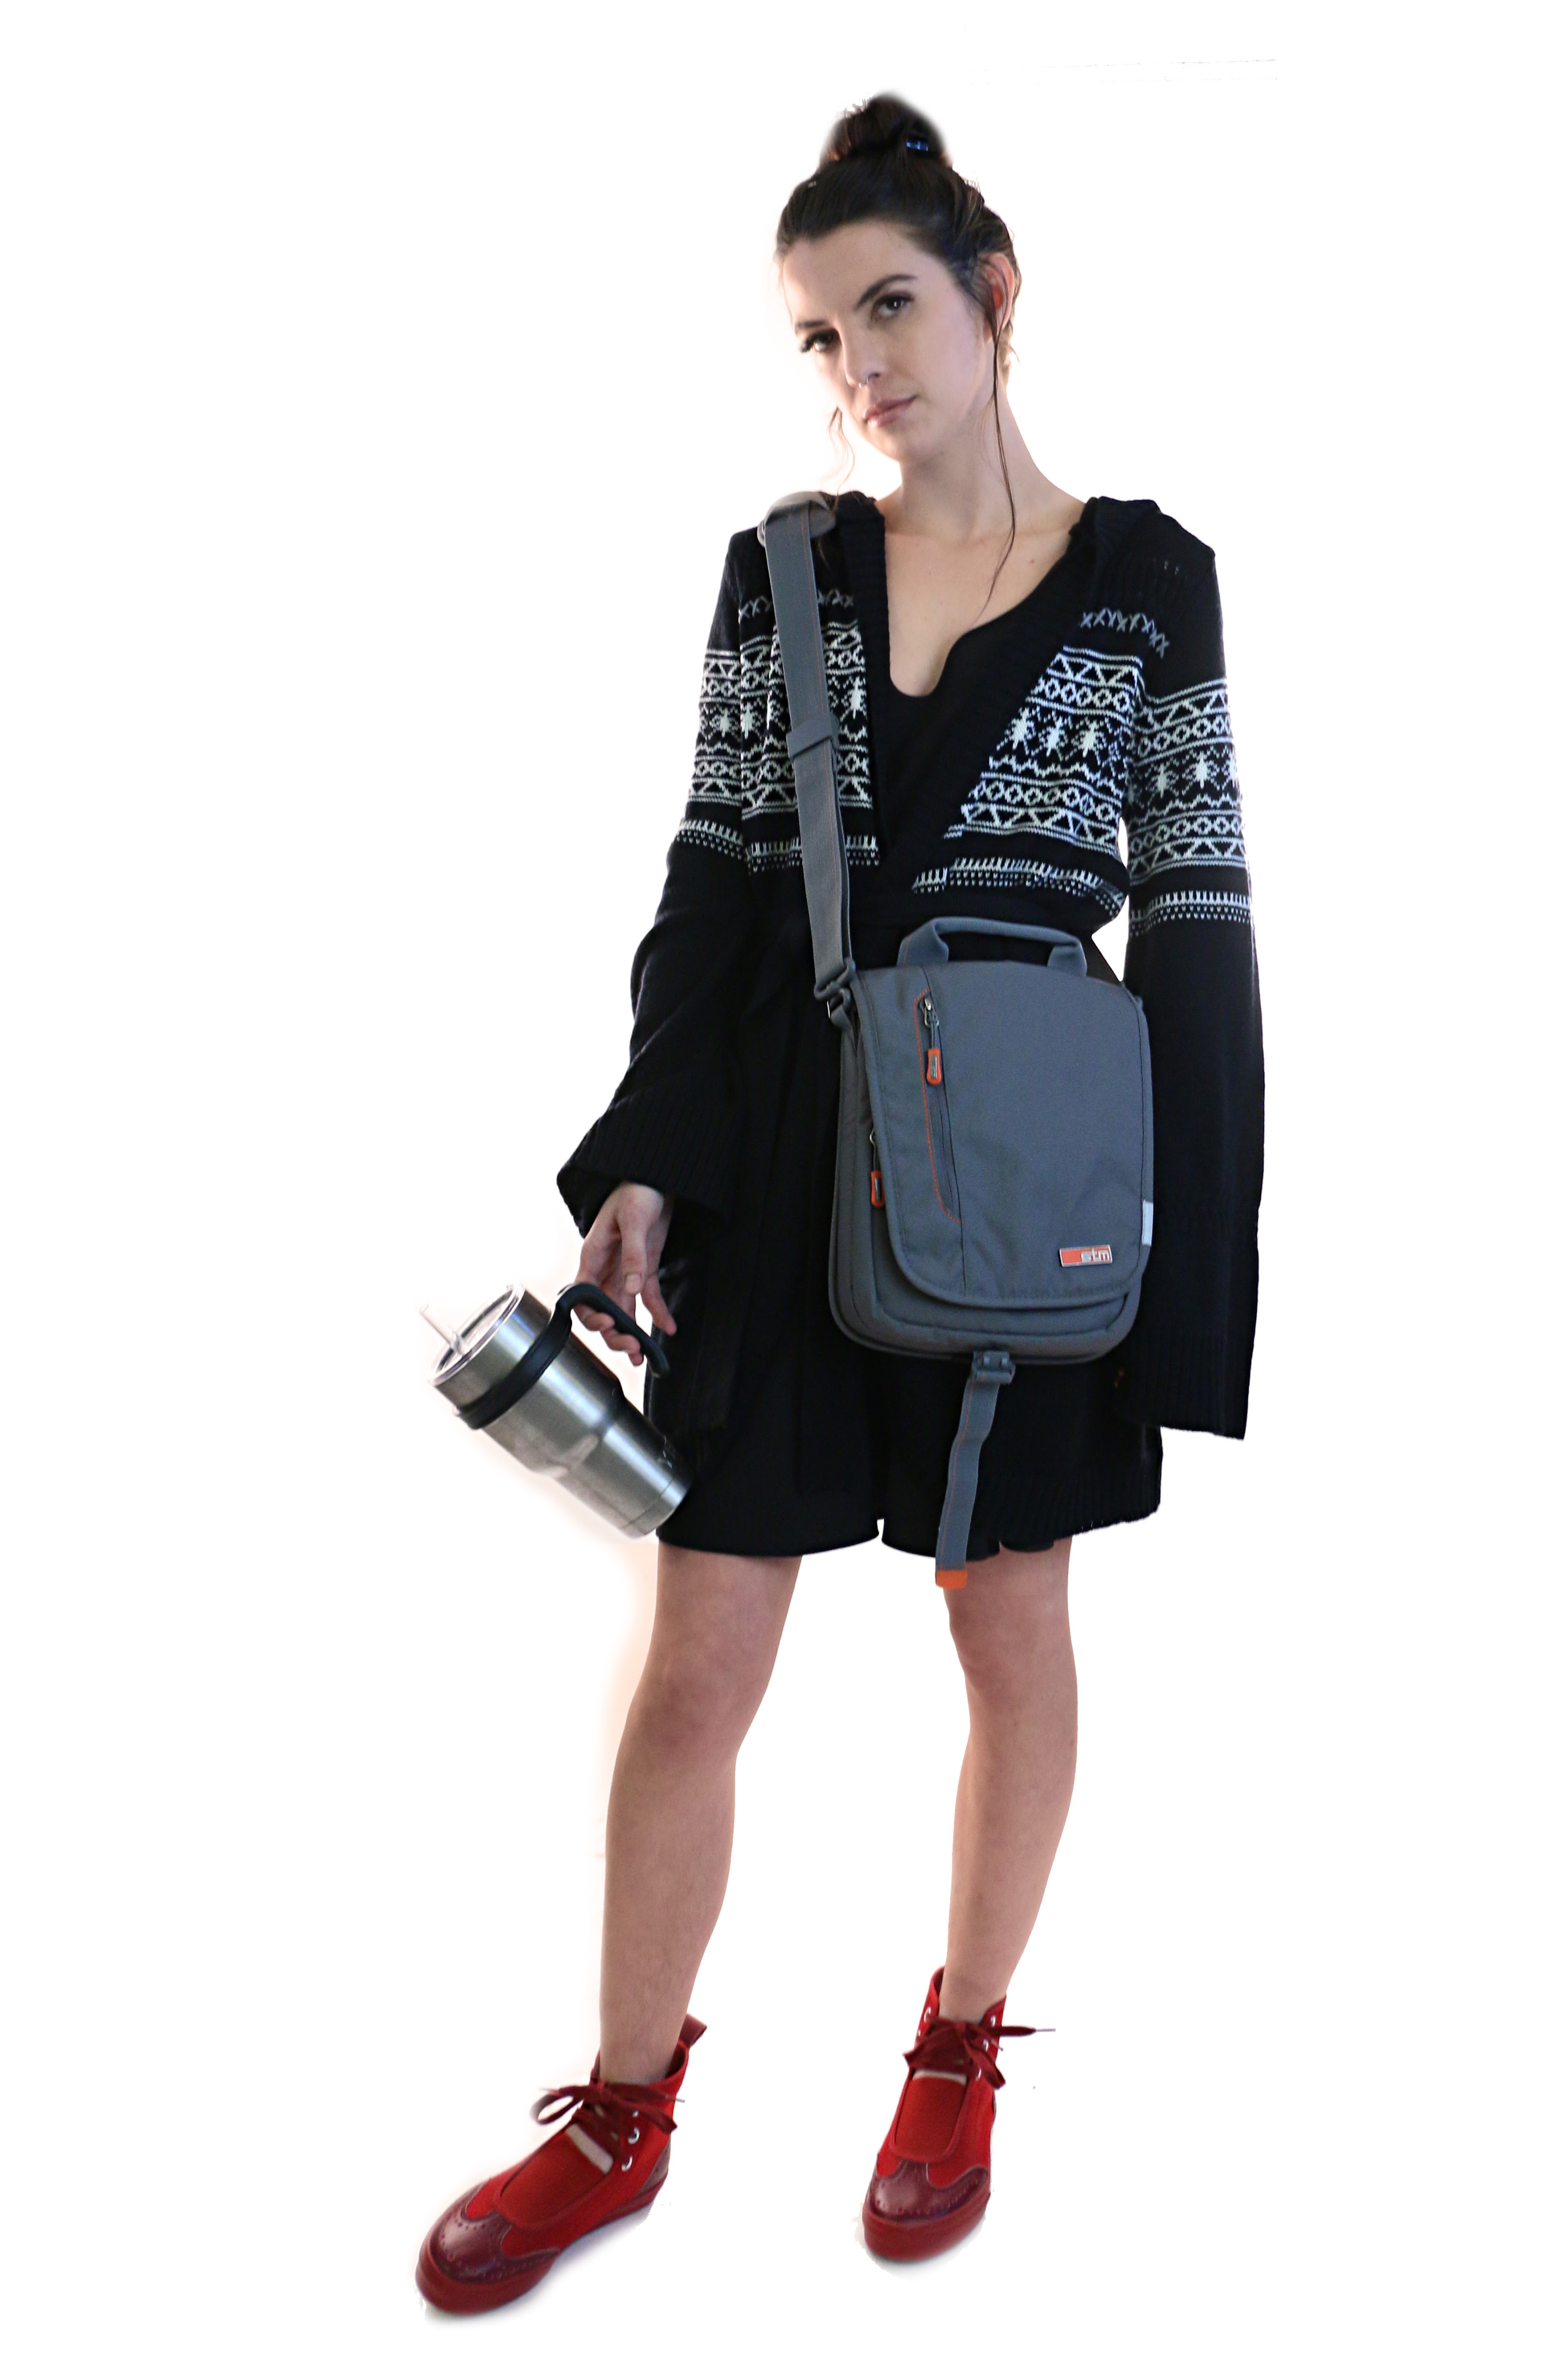
Running Around Town

With the holiday season comes tons of shopping – from picking up groceries for a delicious meal to buying presents for your family, and of course stopping by My Sister’s Closet for some amazing designer fashion finds.

Style it with an adorable knit sweater, like this Yaya Aflalo sweater for only $14.95, to stay warm in the mornings. Pair it with these comfortable Yohji Yamamoto red shoes for $195.00 (retailed for $400) that won’t slow down a woman on the run and this STM cross body bag for $14.95 to hold all of your shopping lists and daily necessities.

Working Through the Day

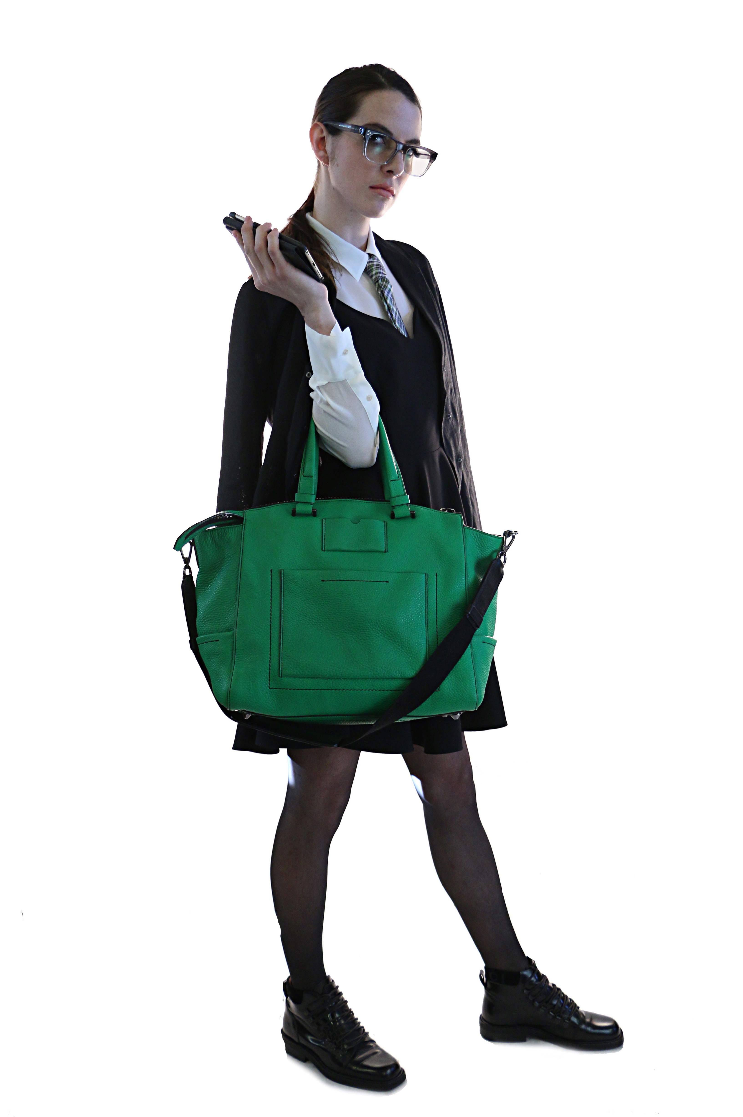
For a busy career woman, this take on the LBD is great for the office or even if your job takes you away from your desk. In the mad rush to tie up loose ends before the end of the year and of course the excitement of time off for the holidays, this outfit is perfect for any woman on the go.

Layer a collared blouse, like this white Elizabeth and James top for $44.95, under your classic LBD to give it a more structured feel. Top it with a whimsical tie, like this Penguin tie for $14.95, to show off some personality and throw on a cute jacket, like this one from Babette for $99.95 (retailed for $495), to take off the chill from the winter weather. And for accessories? These Gucci black shoes for $145.00 (retailed for $550) keep the outfit comfortable, but classic. And off-set this classic look with a bright statement bag, like this Reed Krakoff handbag for $795.00 (retailed for $1,700).

Racing to the Holidays
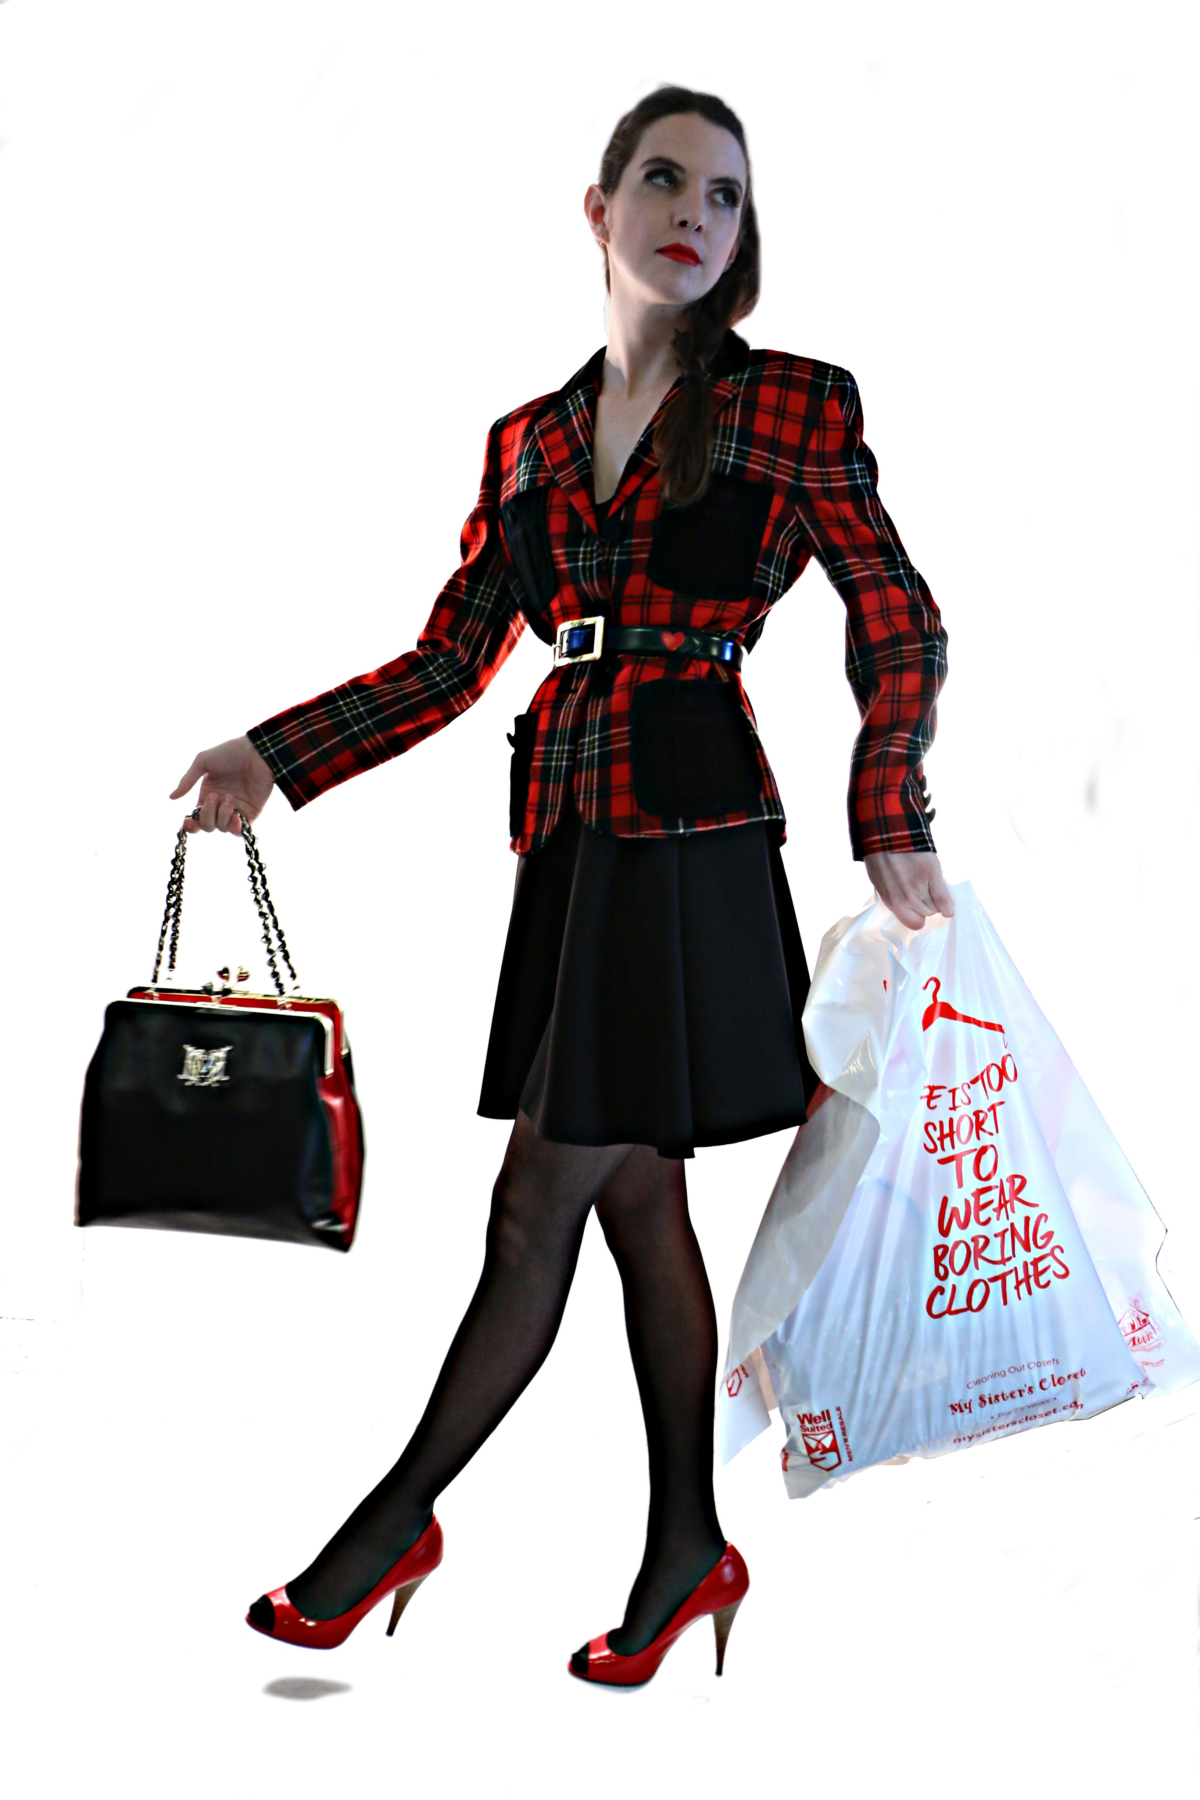
Have Thanksgiving dinner with your family? Brunch on Christmas morning? A holiday get-together with friends? Holiday celebrations always provide a great reason to dress-up and show off your style.

Pull in the traditional holiday red to spice up an outfit that can easily take you from picking up a list minute gift to racing straight to a family gathering.

This great Moschino plaid jacket, only $44.95, is a great addition to your LBD and instantly makes the outfit perfect for the holidays, and show off your waist by adding a cute belt, like this Moschino one for $34.95.

Finish off the look with this beautiful red and black Love Moschino handbag for $99.95 (retailed for $1,000) and these Miu Miu pumps for $79.95 (retailed for $750).

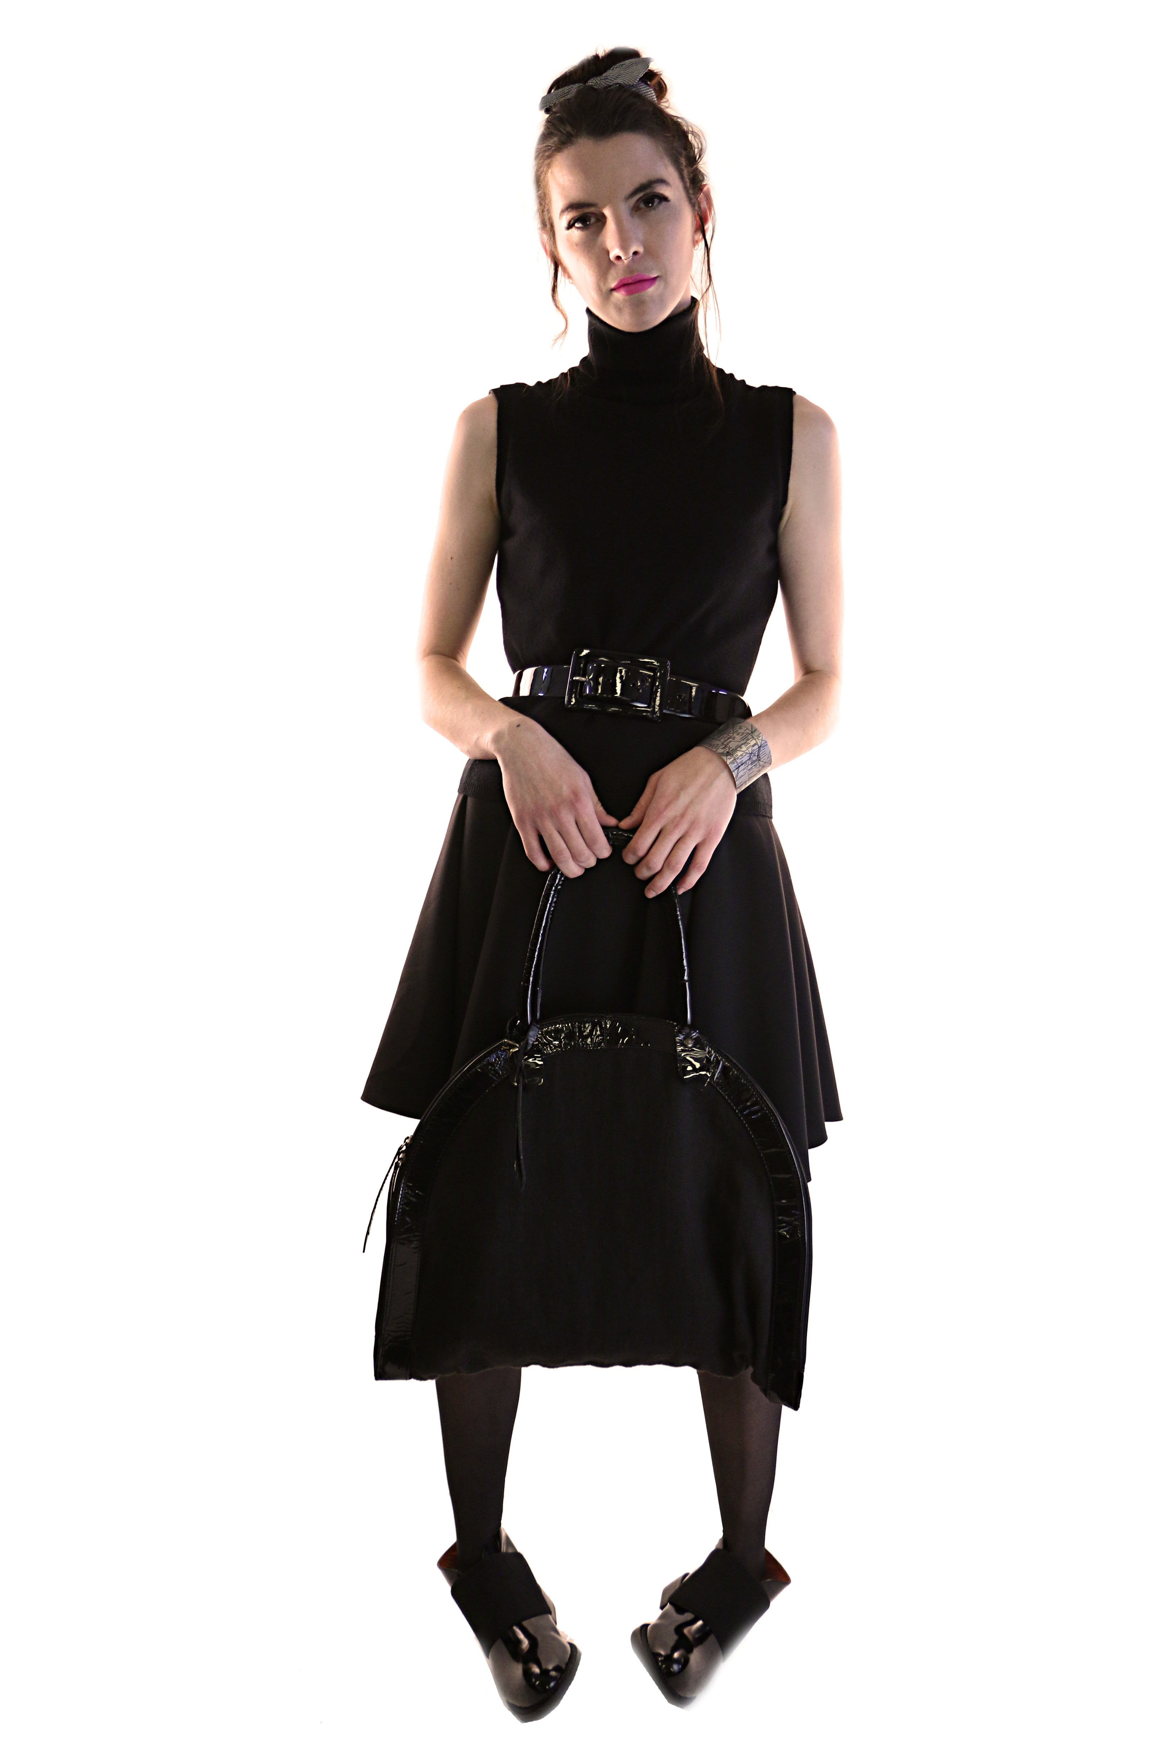
Meeting Up with the Girls
Thanks to Arizona’s warmer winter weather going sleeveless for the holidays isn’t out of the question. For a night out with your girls keep it chic and monochromatic.
A great way to dress for fall in Arizona, this sleeveless turtleneck top by Malo for $44.95 adds a wintery edge to your LBD. Nip in your waist and accessorize all at the same time with this Ralph Lauren belt for $17.50. Add this beautiful Daniele Alessandrini handbag for $49.95 and Jeffrey Campbell booties for $39.95 to finish the look.
Don’t forget the jewelry! Put on a cute cuff and a bowtie, like the ones pictured for only $14.95 and $12.50 to be the envy of all of your friends at happy hour.
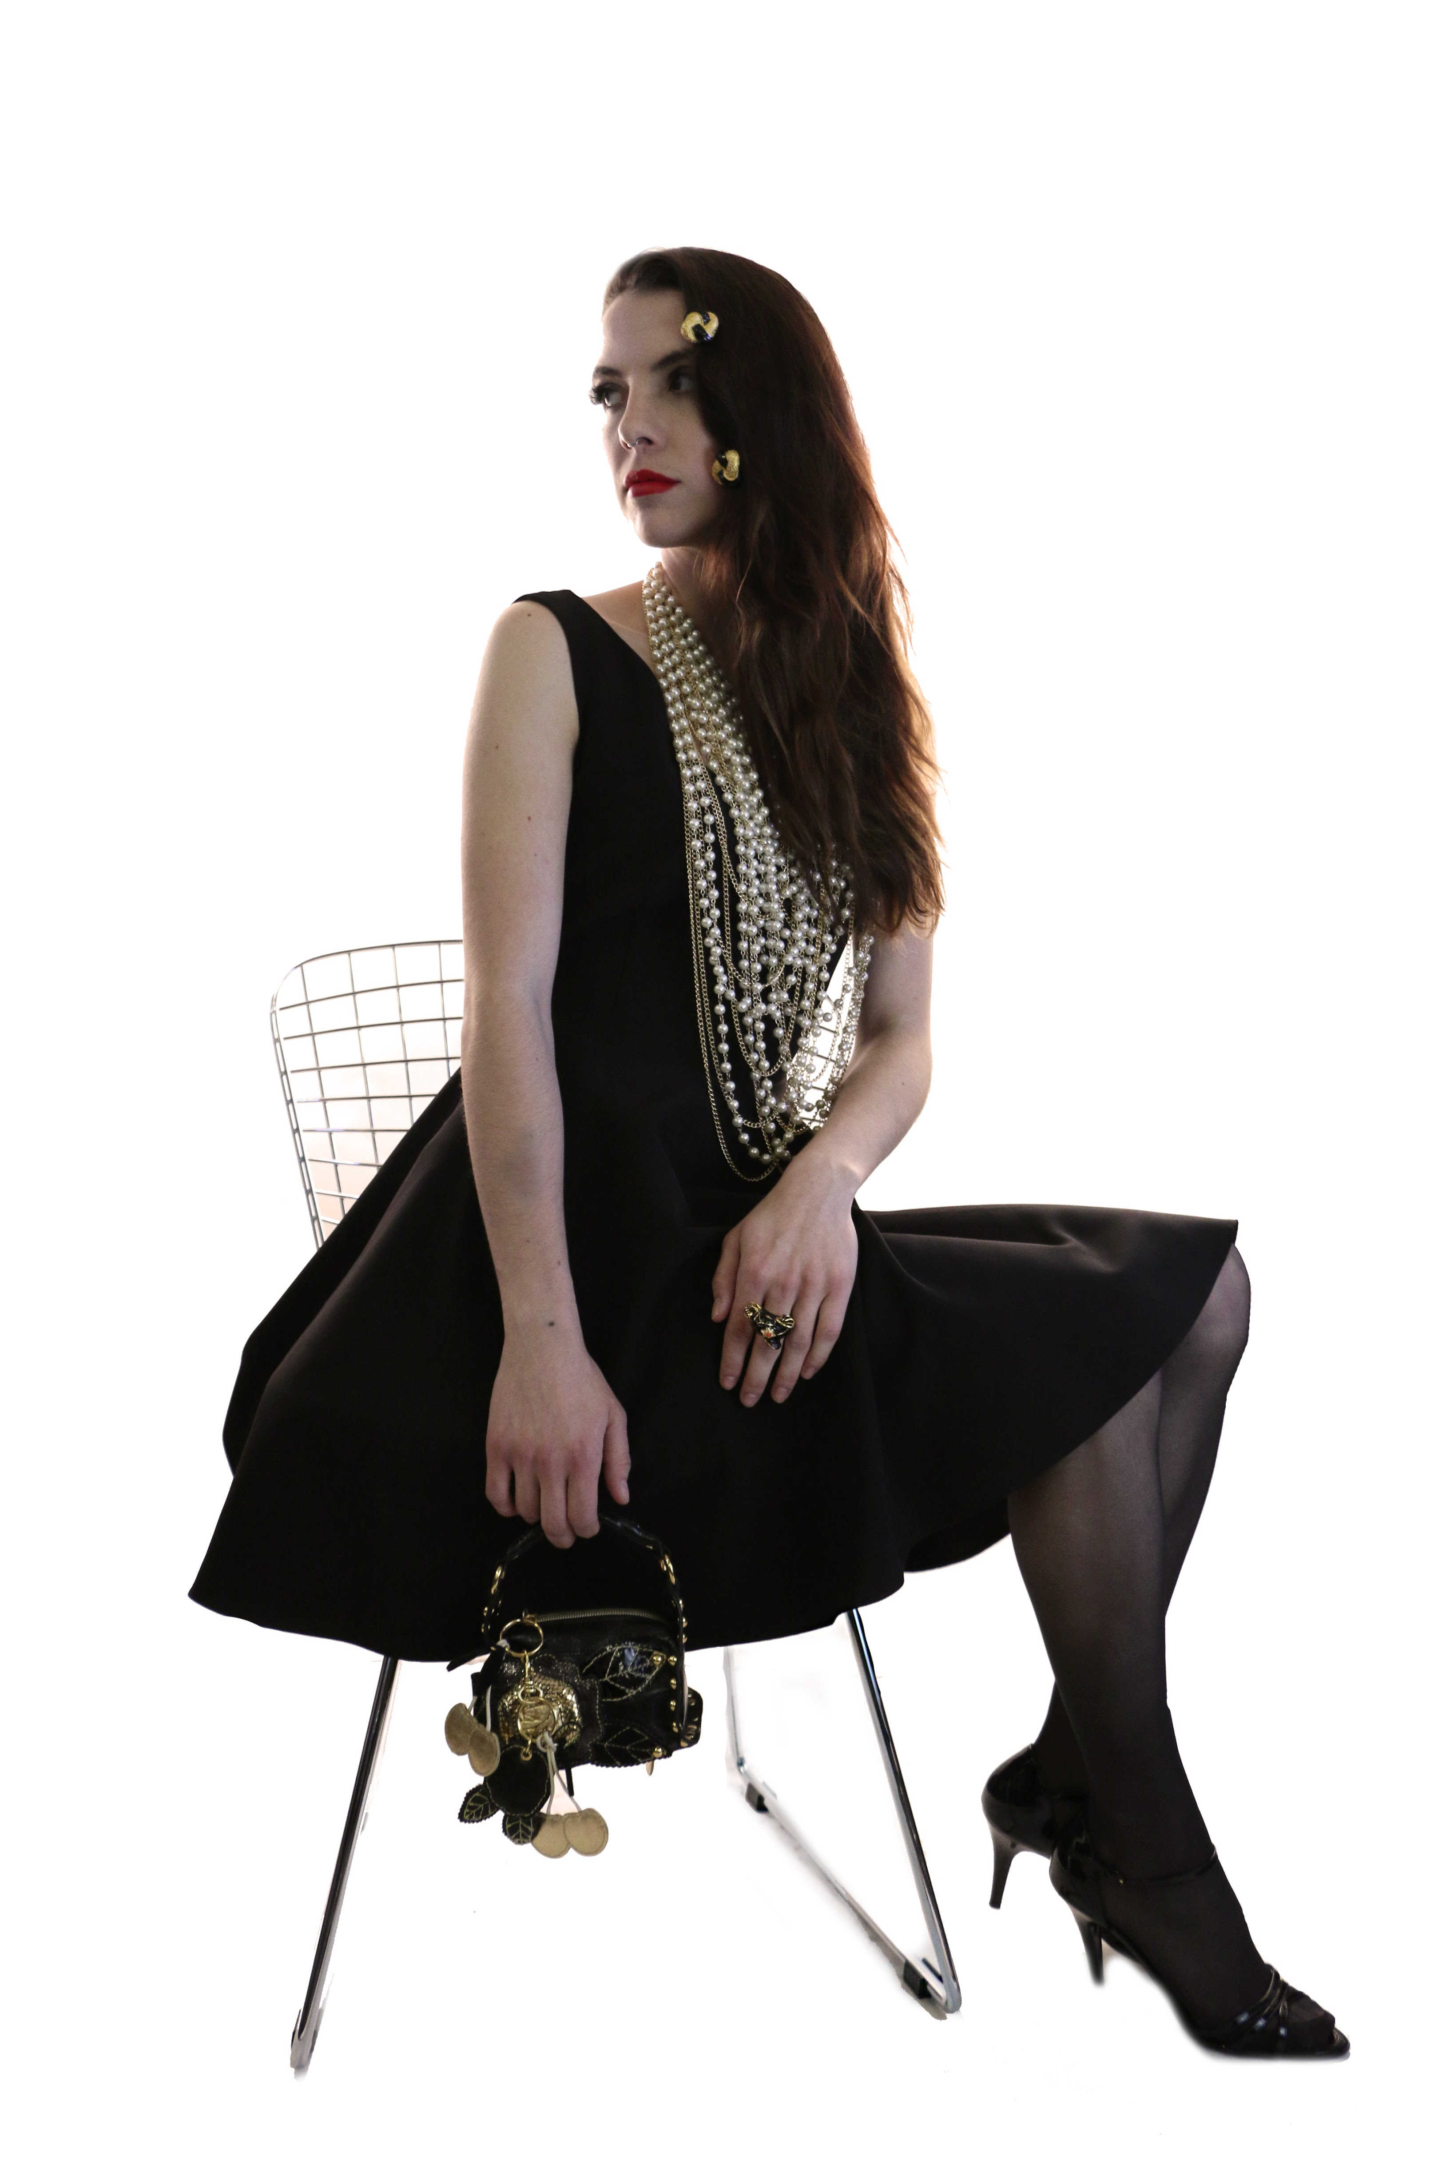
Party Time

Office parties, Christmas gatherings, New Year’s – tis the season for parties!

Let the jewelry do the taking with this party look. Dress up your LBD with a statement necklace like these BeBe strands of pearls for $44.95 and add a fun cocktail ring like this one by KJL for $59.95.

Bring a small bag that holds only the essentials – lipstick, wallet and keys, like this one by Beverly Feldman for $34.95 and slip into a pair of strappy, patent shoes like these Ralph Lauren heels for $125.00.

Shop all of these looks and more at My Sister’s Closet. It’s the perfect place to find gifts for friends and loved ones with something for everyone at My Sister’s Closet, Well Suited and My Sister’s Attic. Don’t forget to pick up a few things for yourself too!

For media inquiries please contact Jennifer Parks at 480.495.3806 or by email at jparks@rosemoserallynpr.com.

Like My Sister’s Closet on Facebook and sign-up to get email updates on the hot ticket items on www.mysisterscloset.com.

My Sister’s Closet Locations (Well Suited located next door):
Desert Village at Pinnacle Peak
23269 N. Pima Rd. Scottsdale, AZ 85255
Phone: 480-419-6242
Mon-Fri: 9am-7pm
Sat: 9am-6pm
Sun: 10am-6pm
Lincoln Village in Scottsdale
6204 N. Scottsdale Rd. Scottsdale, AZ 85253
Phone: 480-443-4575
Mon-Fri: 9am-7pm
Sat: 9am-6pm
Sun: 10am-6pm
Town & Country in Phoenix
4869 N 20th St. Phoenix, AZ 85016
Phone: 602-954-6080
Mon-Fri: 9am-7pm
Sat: 9am-6pm
Sun: 10am-6pm
Las Tiendas in Chandler (Not a Well Suited Location)
2915 S. Alma School Rd. Chandler, AZ 85248
Phone: 480-722-1822
Mon-Fri: 9am-7pm
Sat: 9am-6pm
Sun: 10am-6pm

California Locations
My Sister’s Closet
8610 Genesee Ave., Ste. 200
San Diego, CA 92122
858-455-0045

My Sister’s Closet and Well Suited
146 N El Camino Real
Encinitas, CA 92024
760-436-3600

About My Sister’s Closet and Eco-Chic Consignment:
Eco-Chic Consignments, Inc. is a family of three high-end designer consignment concepts—My Sister’s Closet (women), My Sister’s Attic (home furnishings) and Well Suited (men). Each store sells consigned items at 60 – 90% below retail value. Founded more than 25 years ago, Eco-Chic Consignments, Inc. has since grown into a $25+ million business with 15 locations in some of the nicest neighborhoods of Arizona and California. The company ranked no. 2,896 on the Inc. 5000 list. To learn more about Eco-Chic Consignments, Inc. and its resale brands, visit mysisterscloset.com.

